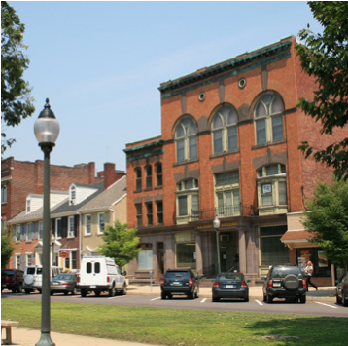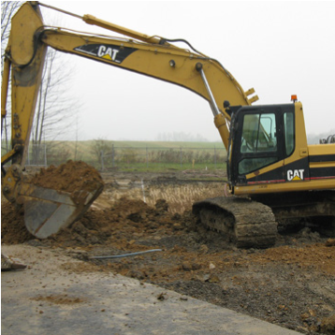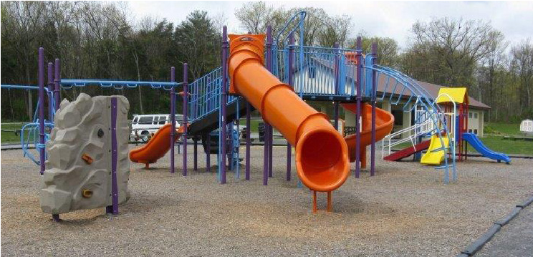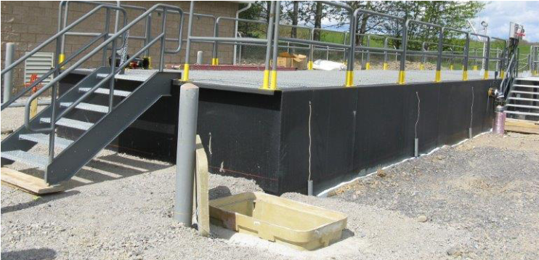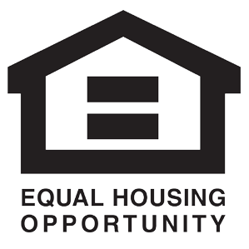
Lycoming County
Third Street Plaza,
33 West Third Street, 3rd Floor,
Room 319
Williamsport, PA 17701

Larissa Hassinger,
Program Analyst
Community Development Program
SEDA-Council of Governments
lhassinger@seda-cog.org
570-524-4491

Lycoming
County
May 20, 2026
6:00 PM
FFY 2026
Community Development
Block Grant Workshop
Learn
Engage
For More
Information
Please Contact
Succeed
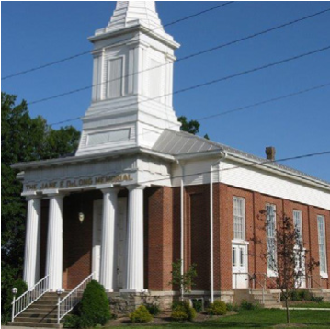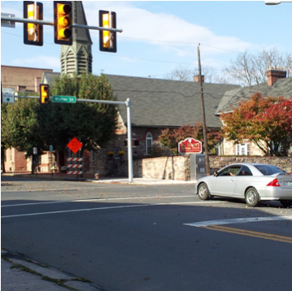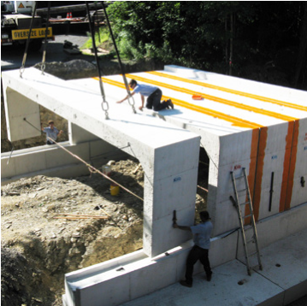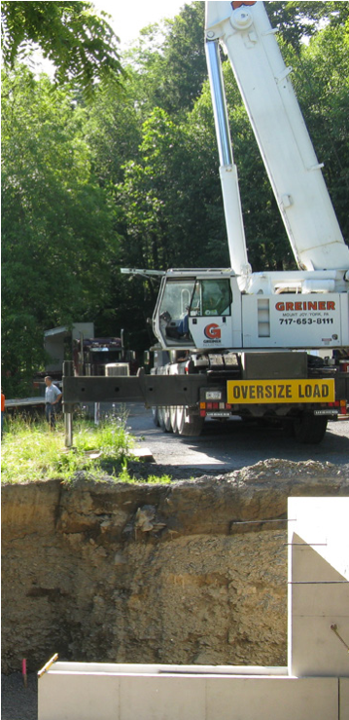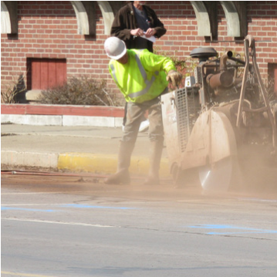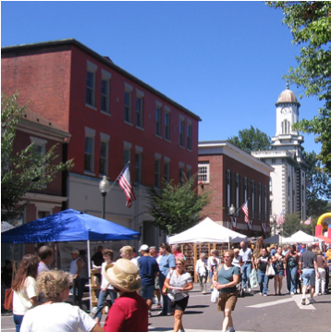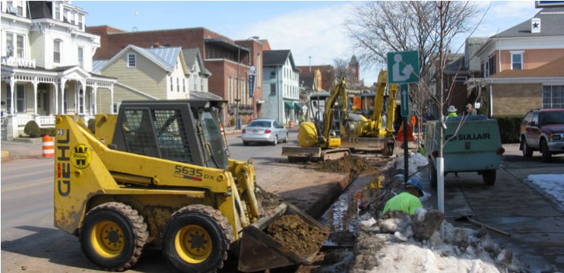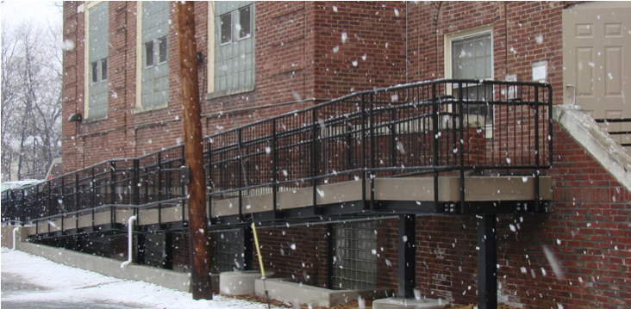
Who Should
Attend?
Lycoming County zzzzzzzzzzzzzz
Community Development
Block Grant Workshop
Are you considering improving
your parks, roads, infrastructure,
community facilities, or starting a
new public service?
This workshop will cover everything you
need to know on how to apply for CDBG
funding and give you an opportunity
to discuss your project with County and
SEDA-COG CD staff. Topics to be covered:
Representatives from municipalities, authorities,
nonprofits, and other community service
organizations. Members of the public are invited
to attend this workshop to discuss project ideas.
Though not required, it may be valuable to have
your engineer or architect attend this workshop.
Attendance is not mandatory; however, this
workshop will enhance the quality of your project
proposal, thereby increasing your likelihood of a
timely and successful application.

- CDBG Program Overview

- Eligible Projects

- Community Survey Process

- Project Budget Development

- Service Area Determination

- Project Proposals

- Funding Requirements

- Selection Process

- Federal Requirements

- Application Process & Schedule

